Intro

* Differential calculus: stuff like tangents of a curve, instantaneous rate of change
* Integral calculus: stuff like the area under the curve
* Important stuff
  + Review functions
  + Review trig
  + Point slope form: y-y1=m(x-x1)
  + When adding functions, the sum’s domain is the intersection of the domain of the 2 addend functions

Limits and Continuity

* Limit: the expected y value as x approaches a certain value from a certain direction/s
* May or may not equal the actual y value at the x
* Does not exist (DNE) means an expectation doesn’t exist given the parameters
* Left-hand limit:
  + Graphically: travel from left to right to the x value you’re approaching. Then see what the y should be
  + With table: look at the y values corresponding to the x values that are less than but leading up to the value in question
  + Notation: $\lim_{x→a-}(f(x))$, where a is the value to approach
* Right-hand limit:
  + Graphically: travel from right to left to the x value you’re approaching. Then see what the y value should be
  + Table: Look at the y values corresponding to the x values that are greater than but leading down to the value in question
  + Notation: $\lim_{x→a+}(f(x))$
* Limit
  + Basically when left and right-hand limits are the same value
  + If they’re different value, it would be DNE
  + The notation would be like the left and right-hand ones, except no + or - sign next to a
* Direct substitution
  + Determining the limit by solving the function with the value x is to approach as the input
* Rational functions
  + Where there should be a hole: limit, as function approaches the hole, is the y coordinate of the hole
  + Where there should be a vertical asymptote: limit, as function approaches asymptote, is -inf, inf or DNE depending on the multiplicity
  + Try multiplying by conjugates, greatest common denominator, etc if 0/0 is encountered
    - Remember that what you multiply to one side of the fraction you need to multiply to the other side too
  + Approaching infinity means the horizontal asymptote
    - The ratio of the leading coefficients
  + Also, check end behaviors
* Rates of growth (greatest to least): exponentials → polynomials → linear → radicals (power <1) → log functions
* Continuity
  + A function is continuous at x=a if $\lim_{x→a+}(f(x))=\lim_{x→a-}(f(x))=f(a)$
  + A function is continuous in an open interval if the above is true for each point the interval
  + A function is continuous in a closed interval [a, b] if the above is true and $\lim_{x→a+}(f(x))=f(a)$ and $\lim_{x→b-}(f(x))=f(b)$
  + A jump discontinuity exists at x=a if $\lim_{x→a+}(f(x))≠\lim_{x→a-}(f(x))$
  + A removal discontinuity exists at x=a if $\lim_{x→a+}(f(x))=\lim_{x→a-}(f(x))≠f(a)$
  + An infinite discontinuity exists at x=a if x=a is a vertical asymptote
* Properties
 $\lim_{x→a}[bf(x)]=b\lim_{x→a}f(x)$

 $\lim_{x→a}[f(x)±g(x)]=\lim_{x→a}f(x)±\lim_{x→a}g(x)$

$\lim_{x→a}[f(x)g(x)]=\lim_{x→a}f(x)\lim_{x→a}g(x)$

$\lim_{x→a}\frac{f(x)}{g(x)}=\frac{\lim_{x→a}f(x)}{\lim_{x→a}g(x)}$

$\lim_{x→a}[f(x)]^{n}=[\lim_{x→a}(f(x))]^{n}$

$\lim_{x→a}f(g(x))=f(\lim_{x→a}(g(x))$

$\lim_{x→a}(f(x+b))=\lim_{x→a+b}f(x)$

+ If when expanding, and something is DNE, check if doing different sides agree with each other (exists) or not (DNE)
    - Example
      * If $\lim_{x→a}[f(x)+g(x)]=\lim_{x→a}f(x)+\lim_{x→a}g(x)$ and $\lim_{x→a}f(x)=DNE$, then only if $\lim_{x→a-}f(x)+\lim_{x→a-}g(x)≠\lim_{x→a+}f(x)+\lim_{x→a+}g(x)$ would the limit actually be DNE
* Squeeze theorem
  + If $f(x)≥g(x)≥h(x)$, then $\lim_{x→a}f(x)=\lim_{x→a}g(x)=\lim_{x→a}h(x)$
  + Used to evaluate limits involving trig ratios
  + Example
 $\lim_{x→0}(x^{2}cos(\frac{1}{x}))$

 $-1≤cos(\frac{1}{x})≤1$  - is the range of the trig part
    - $-(x^{2})≤x^{2}cos(\frac{1}{x})≤x^{2}$//bring back the rest of function
    - $\lim_{x→0}(-(x^{2}))=0$ and $\lim_{x→0}(x^{2})=0$, so due to the squeeze theorem, $\lim_{x→0}(x^{2}cos\frac{1}{x})=0$
* Special limits
$\lim_{x→0}\frac{sinx}{x}=1$

$\lim_{x→0}\frac{1-cosx}{x}=0$

* Intermediate value theorem
  + If f(x) is continuous in [a, b] and $f(a)≠f(b)$, then for every y between f(a) and f(b), a value x exists where f(x)=y
* L’Hopital’s Rule
  + For when indeterminate forms arise
  + Ex: the limit causes 0/0, inf/inf
  + $\lim_{x→a}\frac{f(x)}{g(x)}=\lim_{x→a}\frac{f'(x)}{g'(x)}=\lim_{x→a}\frac{f''(x)}{g''(x)}$ and so on until you no longer have an indeterminate form

Differentiation

* Slope
  + The average rate of change between 2 points
  + Difference quotient
    - The slope
 $\frac{f(a)-f(b)}{a-b}$

 + Secant line: the line passing through the aforementioned 2 points
* Now, if we take the slope over a domain that is infinitely small, we approach taking the “slope” of one point
  + (a-b approaching 0)
* Derivative
  + instantaneous rate of change
 $f'(x)=\lim_{h→0}(\frac{f(x+h)-f(x)}{h})$

 $f'(x)=\lim_{x→a}\frac{f(x)-f(a)}{x-a}$

+ (Limit of the difference quotient)
* Tangent line
  + line with the slope as the derivative and passes through the point of the instance
 $y-y_{1}=f'(x)(x-x_{1})$

 + Horizontal tangent line when the derivative is is 0
  + Vertical tangent line when the derivative is undefined
* Differentiability
  + whether the derivative could be taken at a certain point
  + Must have local linearity at the point
  + Cannot have a discontinuity at the point
  + Cannot be a sharp turn/“Left and right slope” must agree
    - Ex: the vertex of an absolute value function is not differentiable
  + Cannot be at a vertical tangent line
  + Differentiability guarantees continuity
  + To prove differentiability of f(x) at x=a, show
    - Continuity of f(x) at x=a, AND
$\lim_{x→a}f'(x)≠DNE$

* Notations
  + f’(x) is the derivative of f with respect to x
  + f(n)(x) is the nth derivative of f with respect to x
  + df/dx is the derivative of f with respect to x
  + d/dx f(x) is the operation of taking the derivative of f with respect to x
  + $\frac{df}{dx}|_{x=a}$ is the derivative of f with respect to x at a point where x = a
  + $\frac{df}{dx}|_{(a,b)}$ is the derivative of f with respect to x at the coordinate (a, b)
* Rules
  + - Break down function into composite functions to use this rule
    - Expandable for more than 2 components
    - Ex: $\frac{d}{dx}f(g(h(x)))=f'(g(h(x)))*g'(h(x))*h'(x)$
    - Pattern like that for more than 2 components
 $\frac{d}{dx}tan(x)=sec^{2}x$

 $\frac{d}{dx}cotx=-csc^{2}x$

 $\frac{d}{dx}secx=tanxsecx$

 $\frac{d}{dx}cscx=-cotxcscx$

$\frac{d}{dx}b^{x}=b^{x}lnb$

- If b=e, lne = 1 so $\frac{d}{dx}e^{x}=e^{x}$
    - If b<e: derivative is translated to the right of the original
    - If b>e: derivative is translated to the left of the original
 $\frac{d}{dx}log_{b_{}}x=\frac{1}{xlnb}$

   - If b=e, loge=ln. lne=1. So $\frac{d}{dx}lnx=\frac{1}{x}$
 $\frac{d}{dx}f^{-1}(x)=\frac{1}{f'(f^{-1}(x))}$

   - The reciprocal of the derivative of the pre-inverse function at the corresponding/inverted input
$\frac{d}{dx}arcsinx=\frac{1}{\sqrt{1-x^{2}}}$

$\frac{d}{dx}arccosx=\frac{-1}{\sqrt{1-x^{2}}}$

$\frac{d}{dx}arccscx=\frac{-1}{|x|\sqrt{x^{2}-1}}$

$\frac{d}{dx}arcsecx=\frac{1}{|x|\sqrt{x^{2}-1}}$

$\frac{d}{dx}arctan=\frac{1}{x^{2}+1}$

$\frac{d}{dx}arccot=\frac{-1}{x^{2}+1}$

* Higher-order derivative
  + Taking the derivative of a derivative (and so on)
  + Ex: the second derivative of f means find f’ then take the derivative of f’ to find f’’
  + Notation
    - dnf/dxn means the nth derivative of f
    - f with n number of ‘ means the nth derivative of f
* Implicit derivative
  + Implicit equation: an equation that is not in the form y=
  + Ex: x2+y2=55-x
  + To take the derivative of such a function, take the derivative of each side
  + Chain rule application: The implicit equation would have multiple quantities (different variables). When encountering a quantity that isn’t what the derivative operator is operating in respect to, first, take the derivative of that part as normal. Then, “chain on” the derivative of that quantity to that term.
  + Finally, manipulate the whole resulting equation to be in the form of <derivative of the independent variable in respects to the dependent variable>=
  + Ex: $\frac{d}{dx}(y^{3}=x^{2})=(3y^{2}\frac{dy}{dx}=2x) →\frac{dy}{dx}=\frac{2x}{3y^{2}}$
  + Related rates problems: problems where 2 or more quantities are changing with respect to time
  + First, write an equation to model the situation
  + Then, take the derivative of that equation with respect to time
  + Plug in the values of known quantities and solve for the unknowns
  + Ex: a cylinder has a radius of 6 ft and water is drained from it at 3ft3/min. To find the rate of change of the water height
    - Model: V=(pi)r2h → V=(pi)(6)2h
    - Derivative with respect to time: $\frac{dV}{dt}=36π\frac{dh}{dt}$
    - Plug in the knowns: $3=36π\frac{dh}{dt}$
    - Solve for dh/dt for rate of change of the water height

Function Analysis

* Principle function
  + X-intercepts: (x, 0) where f(x)=0
    - Bounce back at even roots
    - Sways through at odd roots
  + Y-intercepts: (0, y) where f(0)=y
  + $\lim_{x→∞}f(x)=∞$ end behavior for positive even and odd functions
  + $\lim_{x→∞}f(x)=-∞$ end behavior for negative even and odd functions
  + $\lim_{x→-∞}f(x)=∞$ end behavior for positive even and negative odd functions
  + $\lim_{x→-∞}f(x)=-∞$ end behavior for negative even and positive odd functions
  + Horizontal asymptote at y= the ratio of the leading coefficient in rational functions
  + Vertical asymptotes at x= where the denominator is undefined
    - Branches go in the opposite direction at odd roots
    - Branches go in the same direction at even roots
  + Slant asymptote has an equation approximate to the quotient of the numerator divided by the denominator of a rational function
  + Holes exist at where factors in the numerator and denominator of a rational function “cancel out”
  + Function is positive when y values are positive
  + Function is negative when y values are negative
  + Function is increasing when the y values increases as the x values increases
  + Function is decreasing when the y values decrease as the x values increases
  + Function is constant when the y values remain the same as the x values increase
  + f(c) is the absolute maximum of f in [a, b] if f(c) is greater than or equal to all f(x) where x is in [a, b]
  + f(c) is the absolute minimum of f in [a, b] if f(c) is less than or equal to all f(x) where x is in [a, b]
  + Extreme value theorem: if f(x) is continuous on [a, b], then f(x) must have a min and a max in [a, b]
  + f(c) is a local maximum on f if f switches from increasing to decreasing at c
  + f(c) is a local minimum on f if f switches from decreasing to increasing at c
  + Endpoints can potentially be absolute extremas, but never local extremas, since there’s nothing to compare to on one side
* First derivative
  + When the first derivative is positive, the principle function is increasing
  + When the first derivative is negative, the principal function is decreasing
  + Where the first derivative changes from positive to negative, the principle function has a local maximum there
  + Where the first derivative change from negative to positive, the principle function has a local minimum there
  + At critical numbers (c where f’(c) = 0 or undefined), if the first derivative changes signs, then the principle function would have an extrema (principle function switches direction)
    - Use a sign chart to determine the sign of the first derivative over different domains to find extremas of the principle function
      * On the AP exam, must use words to explain as well, to get credit
    - If the first derivative bounces instead of changing signs at a critical number, then the principle function might has a terrace point there
      * Terrace point: point on f where f’ = f’’ = 0. No change in direction, but concavity changed

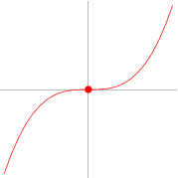

* + A horizontal tangent line exists on the principle function when f’(x)=0
  + A vertical tangent line exists on the principle function when f’(x) = undefined
* Second derivative
  + When the second derivative is positive, the first derivative increases and the principle function is concave up (a curve that can hold water)
  + When the second derivative is negative, the first derivative decreases and the principle function is concave down (a curve that spills water)
  + At critical numbers (c where f’’(c) = 0 or undefined), if the second derivative changes signs, the first derivative would switch direction and the principle function would have a point of inflection (concavity switches)
    - Use a sign chart to check signs of the second derivative over different domains to identify the concavities and inflection points of the principle function. Conclude using words
  + When a curve is concave up, tangent lines lie below the curve
  + When a curve is concave down, tangent lines lie above the curve
  + At an inflection point, the tangent line lies on the graph
  + Second derivative test: let c be a critical number of f’(c). If f’’(c) is positive, then there’s a local minimum on f(x) at c. If f’’(c) is negative, then there’s a local maximum on f(x) at c
* Mean Value Theorem for derivatives: If f(x) is continuous in [a, b] and differentiable in (a, b), then there exists a point at x=c where $f'(c)=\frac{f(b)-f(a)}{b-a}$
  + Rolle’s Theorem: a special case of MVT where if f(a)=f(b), then there must exist a point at x=c where f’(c)=0
* Linear approximation
  + Let’s say there’s a point on a curve you want to know the value of
  + On that curve, find the closest point to the point in question, that you know the value of
  + Find the equation of the tangent line to that point
  + Plug in the x of the point in question to get its estimated value
  + Ex: finding sqrt(1.1) based on y=sqrt(x)
    - Closest point that we know the value of: sqrt(1)=1
    - Tangent line at (1, 1): y=1+0.5(x-1)
    - Plug in 1.1: 1+0.05=1.05 is your approximation (overapproximation)
  + When a curve is concave up, this is an underestimate
  + When a curve is concave down, this is an overestimate
* AP Physics C: Mechanics - Kinematics Lite Edition
  + Position
    - a point in space
    - If position and velocity have the same sign, the particle is moving away from the origin
    - If position and velocity have opposite signs, the particle is moving towards the origin
  + Displacement (x)
    - Vector of distance
    - Distance between an initial and final position
    - Integral of velocity
      * The “c term” would be initial position
  + Velocity (v)
    - Vector of speed
    - Describes the rate of change of position
    - Average velocity: $\frac{Δx}{Δt}$
    - First derivative of position
    - Integral of acceleration
      * The “c term” would be initial velocity
    - Speed increases if the velocity and acceleration are in the same direction, and decreases when signs are opposite
  + Acceleration (a)
    - Describes the rate of change of velocity
    - Average acceleration: $\frac{Δv}{Δt}$
    - Second derivative of position
  + In 2D motion, treat the horizontal and vertical components separately
* Optimization
  + First, write equations to model the constraints
  + Then, write the equation to maximize or minimize
  + Next, write the equation to [max/min]imize in terms of the constraints equations
  + Finally, perform function analysis
  + Ex: find 2 numbers with the greatest product and still sum to 40
    - Constraints: a+b=40
    - Maximize: ab
    - Rewrite: (40-b)b
    - Rewrite equation has a max when b=20
    - a+20=40
    - a=20
    - 20 and 20 has the greatest product while still summing to 40

Integration

* Antiderivatives
  + Indefinite integral
  + What the function is before the derivative is taken
  + Typically named the capital version of the original function name
    - Ex: F(x) is the antiderivative of f(x)
  + Results in a family of function
    - Requires adding a constant c at the end
    - Because every function has a +0 at the end of it, and the antiderivative of 0 is a some constant c
 $\int{}f'(x)dx=f(x)+c$

   - f’(x) is called the integrand
    - x is the variable of integration
    - c is the constant of integration
  + Rules
 $\int{}0dx=c$

 $\int{}kdx=kx+c$

$\int{}kf'(x)dx=kf(x)+c$

$\int{}f'(x)±g'(x)dx=f(x)±g(x)+c$

$\int{}x^{n}dx=\frac{x^{n+1}}{n+1}+c$

$\int{}sinxdx=-cosx+c$

$\int{}cscxcotxdx=-cscx+c$

$\int{}csc^{2}xdx=-cotx+c$

$\int{}cosxdx=sinx+c$

$\int{}secxtanxdx=secx+c$

$\int{}sec^{2}xdx=tanx+c$

$\int{}f'(g(x))dx=\frac{f(g(x))}{g'(x)}+c$

$\int{}b^{x}dx=\frac{b^{x}}{lnb}+c$

$\int{}\frac{1}{x}dx=ln|x|+c$

$\int{}\frac{1}{\sqrt{1-x^{2}}}dx=arcsinx+c=-arccosx+c$

$\int{}\frac{1}{|x|\sqrt{x^{2}-1}}dx=arcsecx+c=-arccscx+c$

$\int{}\frac{1}{x^{2}+1}dx=arctanx+c=-arccotx+c$

$\int{}\frac{1}{\sqrt{a^{2}-x^{2}}}dx=arcsin\frac{x}{a}+c$

$\int{}\frac{1}{|x|\sqrt{x^{2}-a^{2}}}dx=\frac{1}{a}arcsec\frac{|x|}{a}+c$

$\int{}\frac{1}{x^{2}+a^{2}}dx=\frac{1}{a}arctan\frac{x}{a}+c$

+ U-substitution
    - For composite functions
    - First, let u = the inside function
    - Then, find $\frac{du}{dx}$ and manipulate it for dx
    - Next, substitute dx in the original setup with the dx from the previous step
    - Finally, solve
    - For definite integrals, rewrite the limits of integration based on what u would be given the corresponding x
    - Ex:
 $\int{}f'(g(x))dx$     * u=g(x)
 $\frac{du}{dx}=g'(x)$

 $dx=\frac{du}{g'(x)}$

$\int{}\frac{f'(u)}{g'(x)}du=\frac{f(g(x))}{g'(x)}+c$

+ Absolute value
    - Rewrite absolute value function as a piecewise function, then integrate the pieces
  + algebraic manipulations might be needed before integrating
  + Trig identities might be needed before integrating
* Riemann sums
  + One way to approximate the area under a curve is to divide it into quadrilaterals and sum the area of each quadrilateral
  + As the number of quadrilaterals approaches infinity, the estimated area approaches the actual area. Each quadrilateral approaches the shape of a rectangle, with width approaching 0 and height as the value of the curve at a certain point
  + Definite integral in closed interval [a, b]: $\int_{a}^{b}{}f(x)dx=\lim_{n→∞}\sum_{i=1}^{n}{}(\frac{b-a}{n}f(\frac{b-a}{n}i+a))$
  + Right Riemann sum
    - 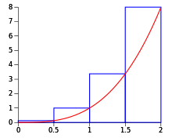
    - Uses rectangles, with width as the width of the subinterval, and height as the function value at the right endpoint of the subinterval
    - Overapproximation when the curve is increasing
    - Underapproximation when the curve is decreasing
    - Summation form for n subintervals: $\sum_{i=1}^{n}{}(\frac{b-a}{n}f(\frac{b-a}{n}i+a))$
  + Left Riemann sums
    - 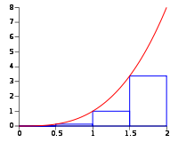
    - Uses rectangles, with width as the width of the interval, and height as the function value at the left endpoint of the interval
    - Overapproximation when the curve is decreasing
    - Underapproximation when the curve is increasing
    - Summation form for n subintervals: $\sum_{i=1}^{n}{}(\frac{b-a}{n}f(\frac{b-a}{n}(i-1)+a))$
  + Midpoint Riemann sums
    - 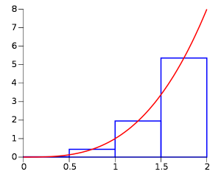
    - Uses rectangles with the width of the subinterval and the height as the function value at the midpoint of the subinterval
    - Overapproximation when the curve is concave down
    - Underapproximation when the curve is concave up
    - Summation form for n subintervals: $\sum_{i=1}^{n}{}(\frac{b-a}{n}f(\frac{b-a}{n}(i-0.5)+a))$
  + Trapezoidal Riemann sum
    - 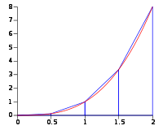
    - Closest estimate
    - Is the average of the left Riemann sum and right Riemann sum
    - Uses trapezoids with height as the subinterval size and has one base with the length as the function value at the left endpoint and another base with the length as the function value at the right endpoint
    - Overapproximation when the curve is concave up
    - Underapproximation when the curve is concave down
    - Summation form for n subintervals: $\sum_{i=1}^{n}{}(\frac{b-a}{2n}(f(\frac{b-a}{n}i+a)+f(\frac{b-a}{n}(i-1)+a)))$
* Definite integral
  + The area under a curve
  + First fundamental theorem of calculus: $\int_{a}^{b}{}f'(x)dx=f(b)-f(a)$
  + a and b are the limits of integration; the interval of the function in which the area under the curve is calculated for
  + To show work for calculating definite integral
    - First, solve the indefinite integral
    - Next, draw a |
    - On the top, write the upper limit
    - On the bottom, write the lower limit
    - Then = sign
    - Then do the first fundamental theorem of calculus
    - Finally, solve
    - Ex: $\int_{a}^{b}{}f'(x)dx=f(x){|^{b}}_{a}=f(b)-f(a)$
    - When u-substitution is involved, change the original limits of integration to be <original variable of integration>=value
    - After the antiderivative is found, the limits should be the output of u given the corresponding input of the <original variable of integration>
    - Ex: $\int_{a}^{b}{}f'(g(x))dx=\int_{x=a}^{x=b}{}\frac{f'(u)}{g'(x)}du=\frac{f(u)}{g'(x)_{}}{|^{b}}_{a}=\frac{f(g(b))-f(g(a))}{g'(x)}$
  + Properties
 $\int_{a}^{b}{}f(x)dx+\int_{b}^{c}{}f(x)dx=\int_{a}^{c}{}f(x)dx$

 $\int_{a}^{a}{}f(x)dx=0$

 $\int_{a}^{b}{}f(x)dx=-\int_{b}^{a}{}f(x)dx$

 - Above the x axis:
      * b>a makes the area positive
      * b<a makes the area negative
    - Below the x axis:
      * b>a makes the area negative
      * b<a makes the area positive
* Average value in an interval: $\frac{\int_{a}^{b}{}f(x)dx}{b-a}$
* Mean value theorem for integrals: if f is continuous in [a, b], then there exists a number c in [a, b] where f(c) = average value of [a, b]
* Integrally defined functions
  + Functions where the independent variable is one of the limits of integration
  + Altering the other limit of integration would vertically translate the function
  + Accumulation function: accumulation of the area under the curve
  + Second fundamental theorem of calculus: $\frac{d}{dx}\int_{c}^{f(x)}{}g(a)da=g(f(x))f'(x)$
  + Initial value problems: $f(x)=\int_{a}^{x}{}f'(t)dt+f(a)$
* Net change theorem: the definite integral of a rate of change function is the net change
* Integrating By Parts
 $\int{}udv=uv-\int{}vdu$

 + For integrands that are products
  + Break up the original integrand into u and dv
    - u should be the factor that’s the easiest to take the derivative of
    - dv should be the factor that’s the easiest to integrate
      * The dx also comes with this factor
    - Find $\frac{du}{dx}$, and use that to find du
    - Find $\int{}dv$ to get v
    - Plug the parts into the formula and solve
  + Tabular method
    - 3 columns: one for sign, one for u, one for dv

| +/- | u | dv |
| --- | --- | --- |
|  |  |  |

* + - Start on the first row: + for the sign, the u factor for u, the dv factor on dv

| +/- | u | dv |
| --- | --- | --- |
| + | x2 | sinx |

* + - Keep taking the derivative of u until it reaches 0

| +/- | u | dv |
| --- | --- | --- |
| + | x2  2x  2  0 | sinx |

* + - For each row, under the sign column, alternate between positive and negative

| +/- | u | dv |
| --- | --- | --- |
| +  -  +  - | x2  2x  2  0 | sinx |

* + - For each row, under the dv column, keep integrating

| +/- | u | dv |
| --- | --- | --- |
| +  -  +  - | x2  2x  2  0 | sinx  -cosx  -sinx  cosx |

* + - Group things like this to form terms

| +/- | u | dv |
| --- | --- | --- |
| +  -  +  - | x2  2x  2  0 | sinx  -cosx  -sinx  cosx |

$\int{}x^{2}sinxdx=-x^{2}cosx+2xsinx+2cosx+c$

* Partial fraction decomposition
  + Some fractions may need to be decomposed before integrating
  + First, do division if possible (when numerator is a greater degree than denominator)
  + Factor the denominator as much as possible
  + For each factor, use each as their own fraction, having the factor in the denominator. Sum up each of these. Ex: (x+1)(x2-3) → x+1+x2-3=(x+1)(x2-3)
  + If a factor has a multiplicity greater than 1, repeat it by creating a fraction with that factor in the denominator, then another fraction with that factor of one lesser degree in the denominator, repeating until you reach first degree. Ex: (x2-1)3=Ax+B(x2-1)3+Cx+D(x2-1)2+Ex+F(x2-1)1
  + The numerator of a fraction is one degree less than the denominator. Use variables as placeholders. Ex: Ax+1+Bx+Cx2-3=(x+1)(x2-3)
  + Multiply terms by fractions equivalent to 1 to make them have a common denominator
  + Eliminate denominators from equation, since they’re all equal now
  + Expand equation
  + Create a system of equations by comparing the terms on both sides that share the same degree. Ex: Ax+2A+Bx-B3-6x-8; Ax+Bx=6x, 2A-3B=-8
  + Let x = 1 and solve system of equation
* Powers of trigonometric functions
  + Substitute trigonometric identities so that u-substitution would work
* Trig substitution
  + For integrands that contain something in the form of $\sqrt{a^{2}±b^{2}}$
  + Draw a right triangle
  + If $\sqrt{a^{2}+b^{2}}$, label the hypotenuse that length
  + If $\sqrt{a^{2}-b^{2}}$, label any leg that length
  + Based on the pythagorean theorem, label the rest of the sides
  + Label theta at an angle where you can get the simplest trig ratios from
  + Using trig ratios and the drawn triangle, rewrite the integrand to be in terms of theta (ex: $sinθ=\frac{x}{4}⇒x=4sinθ$)
  + Using one of the simpler trig ratios from the drawn triangle, take its derivative to find dx, and substitute that in (ex: $sinθ=\frac{x}{4}⇒cosθ dθ=0.25 dx⇒4cosθ dθ=dx$
  + Then integrate
  + Then using the drawn triangle, rewrite the solution in terms of x
* Improper integrals
  + Integrals that have one or both limits of integration as +/- infinity
 $\int_{a}^{∞}{}f(x)dx=\lim_{c→∞}\int_{a}^{c}{}f(x)dx$

 $\int_{-∞}^{a}{}f(x)dx=\lim_{c→-∞}\int_{c}^{a}{}f(x)dx$

$\int_{-∞}^{∞}{}f(x)dx=\lim_{c→-∞}\int_{c}^{a}{}f(x)dx+\lim_{c→∞}\int_{a}^{c}{}f(x)dx$

+ Integrals over a domain that contain an infinite discontinuity
  + Integral over (a, b] with infinite discontinuity at a
 $\lim_{c→a+}\int_{c}^{b}{}f(x)dx$

 + Integral over [a, b) with infinite discontinuity at b
 $\lim_{c→b-}\int_{a}^{c}{}f(x)dx$

 + Integral over [a, b] with infinite discontinuity at c where c is between a and b
 $\lim_{d→c+ }\int_{a}^{d}{}f(x)dx+\lim_{d→c-}\int_{d}^{b}{}f(x)dx$

 + An improper integral converges if the area can be calculated to be finite
  + An improper integral diverges if the area can be calculated to be infinite
  + Comparison test: if $0≤g(x)≤f(x)$, for $x≥a$
    - If $\int_{a}^{∞}{}f(x)dx$ converges, $\int_{a}^{∞}{}g(x)dx$ converges
    - If $\int_{a}^{∞}{}g(x)dx$ diverges, $\int_{a}^{∞}{}f(x)dx$ diverges
  + P-test: for a>0, $\int_{a}^{∞}{}\frac{1}{x^{p}}dx$ converges only if p>1
  + Comparison test demo:
    - Will $\int_{3}^{∞}{}\frac{2}{\sqrt[5]{x^{2}-x-3}}dx$ converge?
    - Step 1: take a function that you know through p-test whether it converges or diverges, that’s close to the original function
 $\frac{2}{x^{\frac{2}{5}}}$

   - Step 2: identify if it converges or diverges
      * p<1, so diverges
    - Step 3: compare which function is greater
 $\frac{2}{x^{\frac{2}{5}}}<\frac{2}{\sqrt[5]{x^{2}-x-3}}$

   - Step 4: apply comparison test
      * The smaller function diverges, so the larger function must diverge

Differential Equations and Slope Fields

* Differential equations contain at least one derivative in them, and the unknown to solve for is a function found in the derivative operator
* A general solution is a family of functions that satisfy the equation
* A particular solution is one that considers an initial condition, or a point that the solution function is known to contain
* The domain of the solution is the interval in which the function is defined, differentiable and contains the initial condition if known
* Separable
  + Differential equation with 2 variables and can be manipulated so that terms with one variable are only on one side and terms with the other variable only on the other side (including the parts of the derivative operator, which could be treated as a fraction in this case)
  + Ex: $\frac{dy}{dx}=xy⇒\int{}\frac{dy}{y}=\int{}xdx$
  + Rewrite → separate → integrate
  + Only one constant of integration is needed, and can go on either sides
* Slope fields
  + For a general solution of a differential equation, this is a coordinate grid with select points having a short line segment representing the slope of a tangent line of the solution if it were to contain that point
  + Presents the general shape of the solution
  + To match a slope field to a function, find the equation of the derivative and determine what parts of the slope field would you expect to find certain slopes (ex: 0, +, -, und, etc)
* Estimating values
  + Graphically
    - Using a slope field, if an initial value is known, start from there. Then, sketch an estimation of the function. The function should remain parallel to the nearby tangent line segments. Use this sketch to estimate values
  + With a Euler’s method function
 $y_{n}-y_{n-1}=\frac{dy}{dx}(dx)$

   - yn-1 is the previous y coordinate
    - yn is the y coordinate to find
    - dx is the step-size
      * Distance between previous x coordinate and the x coordinate that corresponds to the yn
      * Keep this as small as possible to increase accuracy
    - $\frac{dy}{dx}$ is the given differential equation
      * For x, use the step-size to find the x coordinate corresponding to the yn
      * For y, use the yn
    - May need to repeat until you reach the desired values to estimate for
    - Ex:
 $\frac{dy}{dx}=x-y$     * Side-step: 0.2
      * Initial condition: (0, 1)
      * Estimate y(1.2)
      * y(1.1)-1=(1.1-y(1.1))*0.2
      * y(1.1)=0.8
      * y(1.2)-1=(1.2-y(1.2))*0.2
      * y(1.2)=0.68
  + With a Euler’s method table
    - Columns
      * X
      * Y
 $\frac{dy}{dx}$

 $\frac{dy}{dx}*dx$

  - Put initial condition into first row’s x and y
    - Use initial condition to solve for $\frac{dy}{dx}$ in that row
    - Use that $\frac{dy}{dx}$ to solve for the $\frac{dy}{dx}*dx$ in that row
    - $\frac{dy}{dx}*dx$ = change in y, so next row’s x is current x+sidestep. Next row’s y is current y+ $\frac{dy}{dx}*dx$
    - Repeat until desired value is found
    - Ex
 $\frac{dy}{dx}=2y-4x$     * Initial condition: (0, 1)
      * Step-size: 0.1
      * Find y(0.2)

| x | y | $\frac{dy}{dx}=2y-4x$ | dy |
| --- | --- | --- | --- |
| 0 | 1 | 2(1)-4(0)=2 | 2*0.1 = 0.2 |
| 0+0.1=0.1 | 1+0.2=1.2 | 2(1.2)-4(0.1)=2 | 2*0.1=0.2 |
| 0.1+0.1=0.2 | 1.2+0.2=**1.4** |  |  |

* Logistic differential equation
  + Models things like growth of a certain population
 $\frac{dy}{dx}=ky(M-y)=Mky(1-\frac{y}{M})$

   - Models the rate in which the population is changing, given current population
    - $\frac{dy}{dx}$ = rate of change of population
    - k = proportionality constant
    - M carrying capacity (max population size)
    - y = current population
 $y=\frac{M}{1+ce^{-Mkt}}$

   - Models the population in terms of time
  + Features
    - 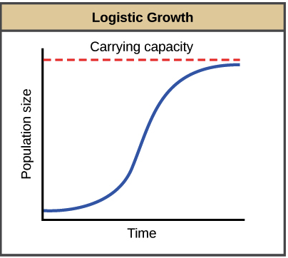
    - Concavity changes from positive to negative at exactly half of the carrying capacity
      * During the first half, the population hasn’t reached capacity yet, so its growth rate can keep increasing. During the later half, the population is getting closer to capacity, so its growth rate must slow down
    - That point of inflection is when the rate of growth is the greatest

$\lim_{t→∞}y(t)=M$

$\lim_{t→∞}\frac{dy}{dt}=0$

Geometry

* Area between 2 functions
  + Sum all corresponding difference S of the 2 functions
  + Vertical difference
    - 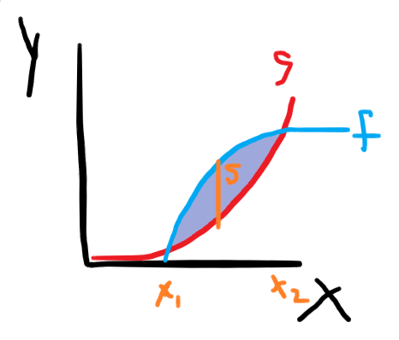
 $S=f(x)-g(x)⇒\int_{x_{1}}^{x_{2}}{}f(x)-g(x)dx$

 + Horizontal difference
    - 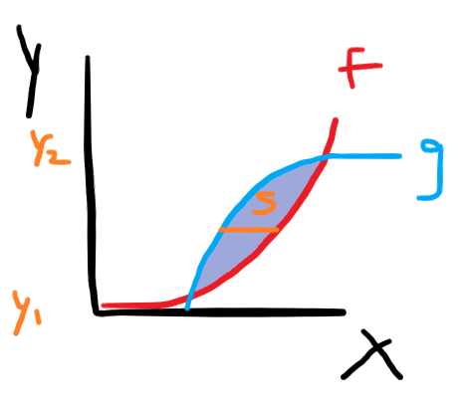
 $S=f(y)-g(y)⇒\int_{y_{1}}^{y_{2}}{}f(y)-g(y)dy$

 + May need to break the area into multiple parts, solve them individually, then sum them back together
* Volume
  + Find an expression representing the cross section area in terms of S, the corresponding difference between the 2 functions that the 3D object’s base is bounded by
  + Sum all the crosssection areas
  + Crosssection perpendicular to the x axis
    - 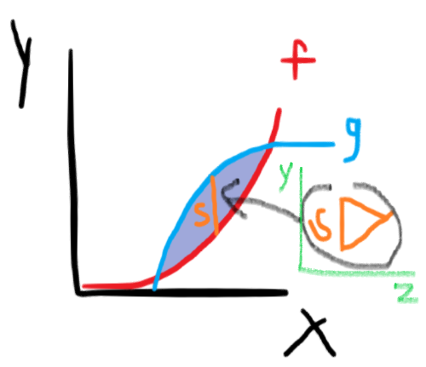
    - Let's say the area of a cross section is $\frac{\sqrt{3}}{4}S^{2}$
 $\frac{\sqrt{3}}{4}\int_{x_{1}}^{x_{2}}{}(g(x)-h(x))^{2}dx$

 + Crosssection perpendicular to the y axis
    - 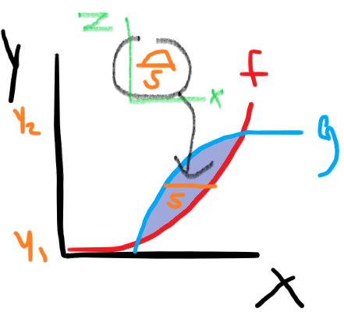
    - Let’s say the area of the cross section is $\frac{π}{8}S^{2}$
 $\frac{π}{8}\int_{y_{1}}^{y_{2}}{}(f(y)-g(y))^{2}dy$

 + Disk revolution
    - For objects where the cross section is a circle
    - Let f(x) be the outer rim of the cross section, and g(x) be the axis to revolve around
    - The area between the outer rim and axis of revolution would have a cross section of a semicircle
    - Area: $\frac{π}{2}S^{2}=\frac{π}{2}(f(x)-g(x))^{2}$
    - Integrate that, but remember that two semicircles make up one full circle (the cross section of the object), so
    - $V=π\int_{a}^{b}{}(f(x)-g(x))^{2}dx$ if cross sections are perpendicular to the x axis
    - If cross sections are perpendicular to the y axis, $V=π\int_{a}^{b}{}(f(y)-g(y))^{2}dy$
  + Washer revolution
    - For objects with crosssections of a donut
    - There are 2 circles involved in the cross section: the outer and inner
    - Find the volume produced by that outer circle, then subtract the volume produced by the inner circle
    - Let f(x) be the outer circle’s rim, g(x) be the inner circle’s rim and h(x) be the axis to revolve around
    - The volume with the crosssection of the outer circle is $π\int_{a}^{b}{}(f(x)-h(x))^{2}dx$, and the volume with the cross section of the inner circle is $π\int_{a}^{b}{}(g(x)-h(x))^{2}dx$
    - The volume of an object with washer cross section perpendicular to the x axis is $V=π\int_{a}^{b}{}(f(x)-h(x))^{2}-(g(x)-h(x))^{2}dx$
    - Crosssection perpendicular to the y axis: $V=π\int_{a}^{b}{}(f(y)-h(y))^{2}-(g(y)-h(y))^{2}dy$
  + Shell method
    - Revolving around a vertical line
 $V=2π\int_{a}^{b}{}rhdx$

   - Revolving around a horizontal line
 $V=2π\int_{a}^{b}{}rhdy$

   - r is an expression representing the distance between the axis of rotation to any given point
    - h is an expression representing the height of a cylinder at any given point
* Curve length

$\int_{a}^{b}{}\sqrt{1+(\frac{df}{dx})^{2}}dx$

$\int_{c}^{d}{}\sqrt{1+(\frac{df}{dy})^{2}}dy$

Parametric and Polar Equations

* Parametric equations
  + x=f(t) describes the x position of a particle at time t
  + y=g(t) describes the y position of a particle at time t
  + f and g are continuous in the interval I
  + t is called the parameter
  + The set of (x, y) coordinates is the graph
  + Altogether, the equations and the graphs are plane curves
  + The direction of a curve as it traces out as t increases is called the orientation
  + To find intersections between two sets of parametric equations
    - tabular/conceptually: t, x, and y has to be the same
    - Algebraically
      * solve one x component for t and substitute that t into the other x component to solve for the x positions where both particles have been in at the same time
      * Substitute those x value(s) into one of the x components to find the t where both particles were at the same x position
      * Substitute the t into both y positions to ensure that at that same t and x, the y is also the same
  + Eliminating the parameter
    - Solve the x or y part for t. Substitute that into the other part
    - Gives you an equation that’s only in terms of x and y
* Differentiation with parametric equations
 $\frac{dy}{dx}=\frac{dy}{dt}÷\frac{dx}{dt}$

 + Horizontal tangent line when $\frac{dy}{dt}=0≠\frac{dx}{dt}$
  + Vertical tangent line when $\frac{dx}{dt}=0≠\frac{dy}{dt}$
 $\frac{d^{2}y}{dx^{2}}=(\frac{d}{dt} \frac{dy}{dx})÷\frac{dx}{dt}$

 + Pathlength: $\int_{t_{1}}^{t_{2}}{}\sqrt{(\frac{dy}{dt})^{2}+(\frac{dx}{dt})^{2}}dt$
  + Speed: $\sqrt{(\frac{dy}{dt})^{2}+(\frac{dx}{dt})^{2}}$
* Polar coordinates
 $(r,θ)$

 + r is the directed distance from point to pole (origin)
  + $θ$ is the directed angle between point and the polar axis (0) in radians. Counterclockwise is positive
  + Rectangular version: $(rcosθ,rsinθ)$
  + To graph: find which way the angle is facing, then from the pole, move r spaces in that direction
  + adding/subtracting pi to $θ$ makes r its opposite
  + 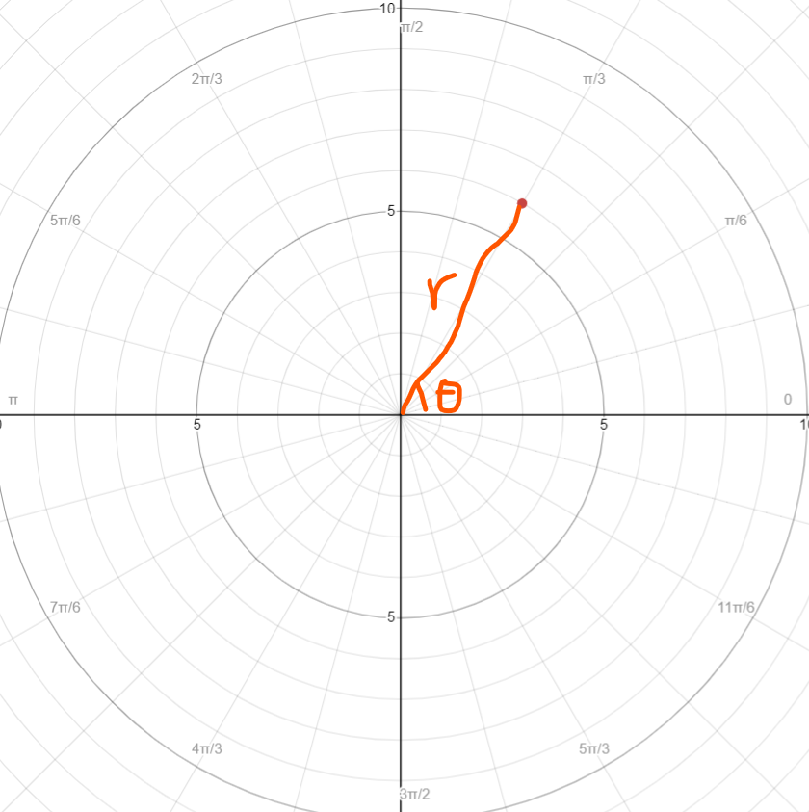
  + Conversions
 $x=rcosθ$

 $y=rsinθ$

$x^{2}+y^{2}=r^{2}$

$tanθ=\frac{y}{x}$

+ Transformations
    - -r($θ$): pi radian rotation
    - r(- $θ$): reflection over $θ$ =0
    - r($θ$ +c): rotation about pole
    - ar($θ$): scales size
  + Rose curve
 $r=acos(bθ)$

   - * a scales petal length
      * cos creates symmetry over the polar axis
      * When b is odd, there are b petals. When b is even, there are 2b petals
 $r=asin(bθ)$     * a scales petal length
      * sin creates symmetry over $θ=\frac{π}{2}$
      * When b is odd, there are b petals. When b is even, there are 2b petals
* Differentiation with polar equations
  + - Slope of the line tangent to the curve
 $\frac{d}{dθ}r(θ)sin(θ) ÷ \frac{d}{dθ}r(θ)cos(θ)$

 $\frac{dr}{dθ}$

  - Rate of change of the distance from particle to pole, as the angle changes
    - If $\frac{dr}{dθ}$ and r have opposite signs, the particle is moving towards the pole
    - If $\frac{dr}{dθ}$ and r have the same signs, the particle is moving away from the pole
 $\frac{dy}{dθ}$

 $\frac{d}{dθ}r(θ)sin(θ)$

  - Rate of change of the distance from particle to x-axis, as the angle changes
    - If $\frac{dy}{dθ}$ and y have opposite signs, the particle is moving towards the x-axis
    - If $\frac{dy}{dθ}$ and y have the same signs, the particle is moving away from the x-axis
 $\frac{dx}{dθ}$

 $\frac{d}{dθ}r(θ)cos(θ)$

  - Rate of change of the distance from particle to y-axis, as the angle changes
    - If $\frac{dx}{dθ}$ and x have opposite signs, the particle is moving towards the y-axis
    - If $\frac{dx}{dθ}$ and x have the same signs, the particle is moving away from the y-axis
* Integration with polar equations
 $0.5\int_{a}^{b}{}(f^{2}(θ)-g^{2}(θ))dθ$

 + Where a is the angle that comes “before” b when going counterclockwise
  + Where f is the polar function of the outer curve
  + Where g is the the polar function of the inner curve (0 if not needed)

Sequences and Series

* Summation rules
$\sum_{i=1}^{n}{}c=nc$

$\sum_{i=1}^{n}{}i=\frac{n(1+n)}{2}$

$\sum_{i=1}^{n}{}i^{2}=\frac{n(n+1)(2n+1)}{6}$

$\sum_{i=1}^{n}{}i^{3}=\frac{n^{2}(n+1)^{2}}{4}$

* Sequences
  + A function whose domain is positive integers
  + an refers to the nth number in the sequence
  + If the limit $\lim_{n→∞}a_{n}=L$ exists, then the sequence converges to L. Else, the sequence diverges.
  + Absolute value theorem: if $\lim_{n→∞}|a_{n}|=0$, $\lim_{n→∞}a_{n}=0$
  + Recursive formula: one statement that defines a known value in the sequence. A second statement that defines how to get from the previous term to the next term
  + Explicit formula: a single statement that you can substitute the value of n for to get the nth value in the sequence
  + Arithmetic sequence: the difference between consecutive terms is constant
    - Recursive: a0=somevalue, an=an-1+d
    - Explicit: an=a1+d(n-1)
  + Geometric sequence: the ratio between consecutive terms is constant
    - Recursive: a0=somevalue, an=an-1r
    - Explicit: an=a1rn-1
* Series
  + The sum of all elements in a sequence
 $\sum_{n=starting index}^{ending index}{}sequence$

 + Arithmetic series
    - Finite
 $\frac{a_{1}+a_{n}}{2}*n$     * Where a1 is the starting and an is the ending term, and n is the number of terms
  + Geometric series
    - finite
      * Aka nth partial sum
 $a_{1}\frac{1-r^{n}}{1-r}$     * Where a1 is the starting term, r is the common ratio, and n is the number of terms
    - Infinite
      * If $|r|≥1$, the series diverges
      * If $|r|<1$, the series converges to $\frac{a_{1}}{1-r}$, where a1 is the starting term and r is the common ratio
        + Because when $|r|<1$, ${\lim_{n→∞}a_{1}}_{}\frac{1-r^{n}}{1-r}=\frac{a_{1}}{1-r}$
  + nth term test: if a sequence does not converge to 0, then the series must diverge. Converse is not necessarily true
  + P-series test: for series in the form of $\frac{1}{n^{p}}$, if p>1, then the series converges. Else, it diverges
  + Integral test: if f is positive, decreasing and continuous, then if $\int_{1}^{∞}{}f(x)dx$ converges, then the series f(n) converges. Else, diverge.
  + Direct comparison test: if $0<a_{n}≤b_{n}$ for all of n, then
    - If bn converges, then an must converge
    - If an diverges, then bn must diverge
  + Limit comparison test: if both an and bn are greater than 0 and $\lim_{n→∞}\frac{a_{n}}{b_{n}}$ is a finite positive number, then bn does whatever an does and vice versa
  + Alternating series test: In alternating series $\sum_{n=1}^{∞}{}(-1)^{n}b_{n}$ where bn>0, the series converges if the sequence bn converges to 0 and consecutive elements of sequence bn are decreasing
  + If $\sum{}|a_{n}|$ converges, then $\sum{}a_{n}$ absolutely converges. Converse is not always true
  + If $\sum{}|a_{n}|$ diverges but $\sum{}a_{n}$ still converges, then $\sum{}a_{n}$ is said to be conditionally convergent
  + Riemann’s rearrangement theorem: if a series is conditionally convergent, then its terms can be rearranged to sum to any number
  + Alternating series error: $|S-S_{n}|≤a_{n+1}$
  + Ratio test
 $\lim_{n→∞}|\frac{a_{n+1}}{a_{n}}|$

   - If the value is less than 1, then the series converges
    - If the value is greater than 1, then the series diverges
    - If the value is equal to 1, then the test is inconclusive
    - Underlying idea is to find the growth rate in the function’s end behavior
  + Power series centered at c: ${\sum_{n=0}^{∞}{}a_{n}}_{}(x-c)^{n}$
* Taylor and Maclaurin polynomial
  + Idea: Recall the linear approximation technique. To decrease the error, we could create a quadratic approximation by using an equation that takes into account the second derivative at the selected “center” point. To further decrease the error, we could use a cubic approximation by using an equation that takes into account the third derivative at the selected “center” point. And so on. The higher the degree, the smaller the error.
  + The nth term of a Taylor polynomial where “center” point’s x coordinate is c is $f^{(n)}(c)*\frac{(x-c)^{n}}{n!}$
  + The derivative of the nth term of a Taylor polynomial is $f^{(n)}(c)$
  + When c=0, the polynomial is also a Maclaurin polynomial
  + Lagrange error bound
    - The error between the Taylor polynomial’s estimate and the actual value
 $R_{n}(x)≤\frac{{max|f}^{(n+1)}(x)|*|x-c|^{n+1}}{(n+1)!}$

 + Taylor and Maclaurin series are a special case of power series
    - Find the interval of x where the series is convergent
      * If you use the ratio test, also test the endpoints independently since the ratio test in inconclusive when r=1
    - The polynomial can only approximate a function at a x value that’s in the interval where the series converges
  + Geometric Maclaurin series: $\frac{a_{1}}{1-r}=\sum_{n=0}^{∞}{}a_{1}r^{n}$
* Performing operations on series
  + Derivative of a series: each term simply becomes its derivative
  + Integral of a series: each term simply becomes its antiderivative
  + When a power series is integrated or derivative, the interval of convergence remains the same, except that whether the end points are included can change
  + Multiplication of a series with a non-series: multiply each term of the series with the non-series
  + Composition: substitute “x” for the “inside function”
  + Multiplication of 2 series: write out the first few terms of both series. First, use distributive multiplication to collect the constant products, then the linear products, then the square products, and so on
  + Division of a series by a non-series: just like multiplication of a series by a non-series. Just remember that dividing is just like multiplying with a fraction
  + Sum of a series with a non-series: the non-series just becomes another term
  + Sum of a series with a series: $f(x)±g(x)=\sum_{n=0}^{∞}{}(f_{n}±g_{n})x^{n}$

Misc.

$e=\lim_{n→∞}(1+n^{-1})^{n}=\lim_{h→0}(1+h)^{h^{-1}}≈2.718$